|  |  |
| --- | --- |
| **Reg. #** |  |
| **Marks** |  |

**EXPERIMENT # 3**

**Design and simulation of Controlled Rectifier**

**Controlled rectifiers**

Controlled rectifiers are line commutated ac to dc power converters which are used to convert fixed voltage, fixed frequency ac power supply into variable dc output voltage.

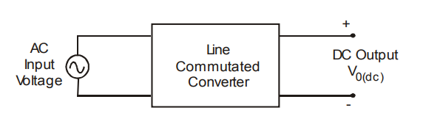

Type of input: Fixed voltage, fixed frequency ac power supply.

Type of output: Variable dc output voltage

The input supply fed to a controlled rectifier is ac supply at a fixed rms voltage and at a fixed frequency. We can obtain variable dc output voltage by using controlled rectifiers. By employing phase controlled thyristors in the controlled rectifier circuits we can obtain variable dc output voltage and variable dc (average) output current by varying the trigger angle (phase angle) at which the thyristors are triggered.

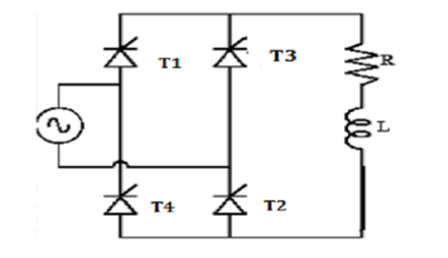

Figure 1: Single Phase Full Wave Rectifier

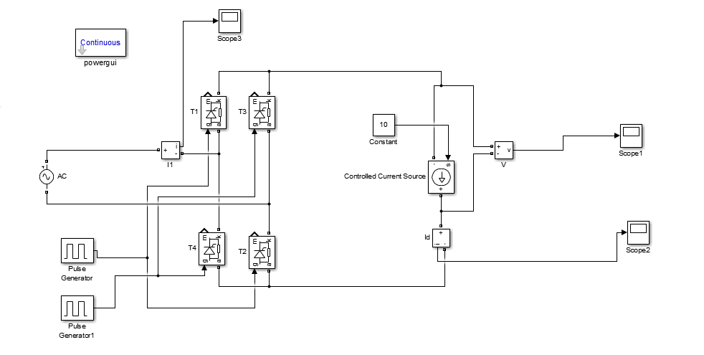

Figure 2: Single phase Converter using PWM generator with DC machine

**Tasks:**

* Design the AC/DC converter in Matlab/Simulink use resistor in place of current source.
* Observe the output voltage waveform at 0, 30, 60, 90, 120 degree with current source.
* Observe the output voltage waveform after including Line Inductance at 0, 30, 60, 90, 120 degree with current source.
* Observe the output current waveform with DC machine at 30 degree.

Design the converter and simulate in MATLAB. Put a snapshot of your Simulink file result below.

